Chapter 2, Solution 77

(a) 5 Ω = 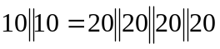
i.e., four 20 Ω resistors in parallel.

(b) 311.8 = 300 + 10 + 1.8 = 300 + 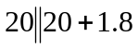
i.e., one 300Ω resistor in series with 1.8Ω resistor and
a parallel combination of two 20Ω resistors.

(c) 40kΩ = 12kΩ + 28kΩ = 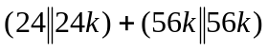
i.e., Two 24kΩ resistors in parallel connected in series with two 56kΩ resistors in parallel.

(d) 52.32kΩ = 28k+24k+300+20 = 56k||56k+24k+300+20

i.e., A series combination of a 20Ω resistor, 300Ω resistor, 24kΩ resistor, and a parallel combination of two 56kΩ resistors.

